**Flask Installation:** <https://pypi.org/project/Flask/>

**Flask Quick Start:** <https://flask.palletsprojects.com/en/1.1.x/quickstart/>

**Command Prompt Cheatsheet:**

1. MAC: <https://gist.github.com/poopsplat/7195274>
2. Windows: <http://www.cs.columbia.edu/~sedwards/classes/2015/1102-fall/Command%20Prompt%20Cheatsheet.pdf>

[**__main__**](https://docs.python.org/3/library/__main__.html#module-__main__)**— Top-level script environment:** <https://docs.python.org/3/library/__main__.html>

**Routing:** <https://flask.palletsprojects.com/en/1.1.x/quickstart/#routing>

**Variable Rules:** <https://flask.palletsprojects.com/en/1.1.x/quickstart/#variable-rules>

**Giffy website link:** <https://giphy.com>

454,455

**Decorator:**

def make_bold(function):

def wrapper():

return "<b>" + function() + "</b>"

return wrapper

def make_emphasis(function):

def wrapper():

return "<em>" + function() + "</em>"

return wrapper

def make_underlined(function):

def wrapper():

return "<u>" + function() + "</u>"

return wrapper



Project - Higher or Lower URLs

Now it's time to complete the project, the higher lower game

1. Create a new project in PyCharm called **higher-lower**, add a **server.py** file.

2. Create a new Flask application where the home route displays an <h1> that says "Guess a number between 0 and 9" and display a gif of your choice from [giphy.com](https://giphy.com/).

Alternatively use the one I found on Giphy: https://media.giphy.com/media/3o7aCSPqXE5C6T8tBC/giphy.gif

3. Generate a random number between 0 and 9 or any range of numbers of your choice.

4. Create a route that can detect the number entered by the user e.g "URL**/3**" or "URL**/9**" and checks that number against the generated random number. If the number is too low, tell the user it's too low, same with too high or if they found the correct number. try to make the <h1> text a different colour for each page.  e.g. If the random number was 5:

3 is too low:

7 is too high:

and 5 is just right:

Here are the GIF URLs I used, but it's way more fun finding your own on giphy.com

High: https://media.giphy.com/media/3o6ZtaO9BZHcOjmErm/giphy.gif

Low: https://media.giphy.com/media/jD4DwBtqPXRXa/giphy.gif

Correct: https://media.giphy.com/media/4T7e4DmcrP9du/giphy.gif



Render_Template: <https://flask.palletsprojects.com/en/1.1.x/quickstart/#rendering-templates>

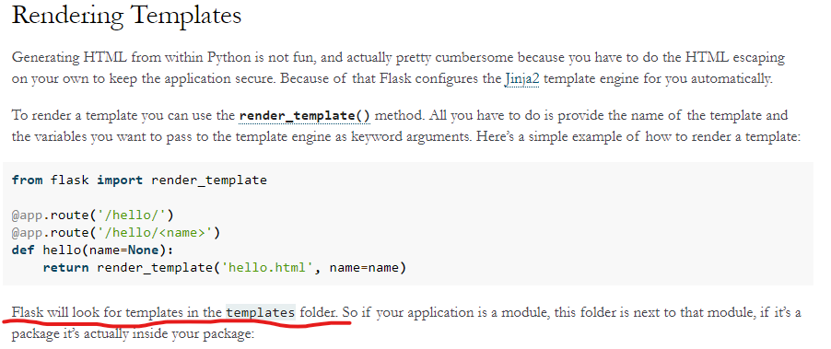

Project:

1. Take a look at the live demo here:

<https://html5up.net/identity>

2. Create a new PyCharm project called name-card and create a new Flask Application from scratch.

3. Create the necessary folders and move the relevant files from the download in step1.

4. Get the website to work when you access the root route ("/")

5. Personalise the website, change the background image, change the text, change the links, make it your own.

This is what you're aiming for:

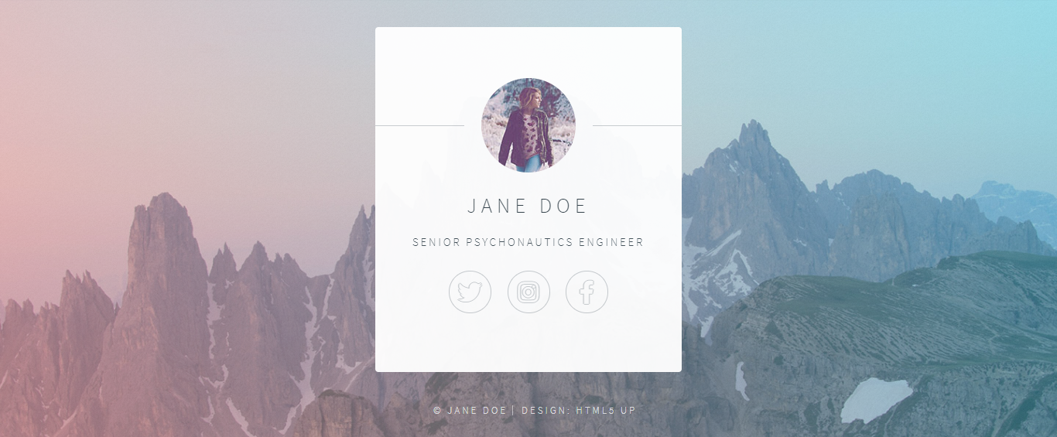

To download image: <https://unsplash.com/>